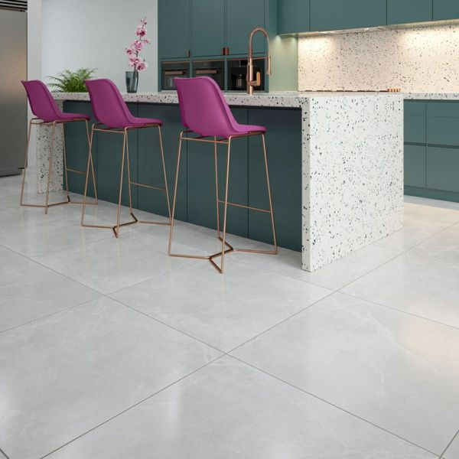**Stonemood White Tiles:**

## **Product DESCRIPTION**

Stonemood is an extra-large format range inspired by natural stone, it has a gentle veining to give character and movement, with a soft matt finish, perfect for creating the concept of seamless living. Available in two subtle neutral colourways creating a calm tranquil space. Made in a thinner 8mm porcelain composition whilst still maintaining its hard wearing and durable characteristics of a 10mm porcelain with the same breaking strength. The advantage of the 8mm is a lighter option for handling.

What's special about these tiles?

> They are a stunning white stone effect.

> Their large size is ideal for open-plan living spaces to create a seamless effect.

> Their 8mm thickness reduces their weight and also makes them suitable for underfloor heating.

> Their ceramic body is practical and hard-wearing, yet beautiful.

## **Product Info**

* Product ID: 44339
* Tiles Per SQM: 1.5742849991105
* Sale by: Per SQM
* Size: 797x797x8mm
* Weight: 7.64 KG
* Material Type: Porcelain
* Finish: Matt
* Colour: Grey
* Suitability: Floors
* Grade: 4
* Rectified Edge: Yes
* Underfloor Heating: Yes
* Thickness (mm): 8